Music 4745 Midterm

Written Exam

Student’s Name:

What is the difference between the *line* and *line~* objects? [ /6 points]

Draw the shape of the waveforms that the *cycle~*, *tri~*, *saw~*, and *rect~* objects produce. [ /6 points]

What is the highest frequency that can be correctly sampled with a sampling rate of 44.1kHz? With 96kHz? What is the name of this frequency as it relates to the Nyquist Theorem? [ /10 points]

What will be the frequencies of the positive and negative sidebands of a ring modulator be if the carrier is a 1550Hz sine wave and the modulator is a 250Hz sine wave? [ /6 points]

What will the result be when the button is clicked one time? What about a second time? [ /8 points]

What is the difference between an *encapsulation* and an *abstraction*? Give an example of an instance where it would be beneficial to use an abstraction over an encapsulation. [ /6 points]

Next to each object, label and describe what each object in the following patch does in the patch. What is an object that could be used in place of the [random 128]-[+ 200] objects that would create the same effect? [ /10 points]

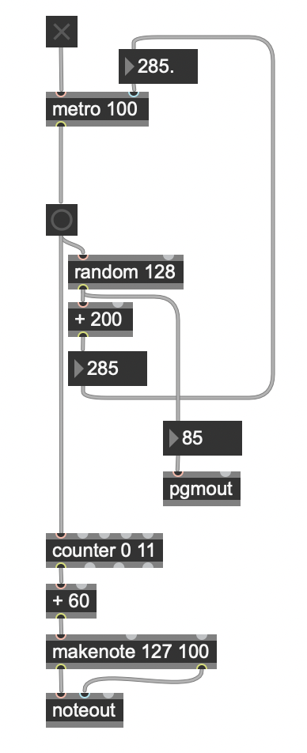

Describe an idea you have for the audio processor you will be creating in weeks 11-12. You may draw a diagram or list a few objects you are interested in using. [ /4 points]